Module 4) JAVASCRIPT BASIC & DOM

Q.1 What is JavaScript. How to use it?

A-1) JavaScript is a scripting or programming language that allows you to implement complex features on web pages

* every time a web page does more than just sit there and display static information for you to look at
* displaying timely content updates, interactive maps, animated 2D/3D graphics, scrolling video jukeboxes, etc.

### Q.2 How many type of Variable in JavaScript? A-2) There are 3types of variable in javascript.

* Using var
* Using let
* Using const

### **var:** Declares a variable. It has a function-scoped or globally-scoped behavior.

### **let:** Introduces block-scoped variables. It’s commonly used for variables that may change their value.

### **const:** Declares variables that cannot be reassigned. It’s block-scoped as well.

### Q.3) Define a Data Types in js?

A-3) JavaScript includes primitive and non-primitive data types.

* The primitive data types in JavaScript include string, number, boolean, undefined, null, and symbol.
* The non-primitive data type includes the object.

Q.4) Write a mul Function Which Will Work Properly When invoked with Following Syntax.

A-4) The **MUL function** is a miniature of the multiplication function.

**Syntax:**

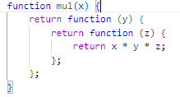

For Example:

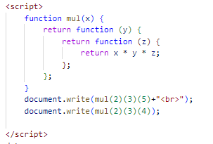

Output:

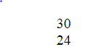

Q.5) What the deference between undefined and undeclared in JavaScript?

A-5)

* Undefined: It occurs when a variable has been declared but has not been assigned any value. Undefined is not a keyword.
* Undeclared: It occurs when we try to access any variable that is not initialized or declared earlier using the var or const keyword.

Q.6) Using console.log() print out the following statement: The quote 'There is no exercise better for the heart than reaching down and lifting people up.' by John Holmes teaches us to help one another. Using console.log() print out the following quote by Mother Teresa:

A-6)

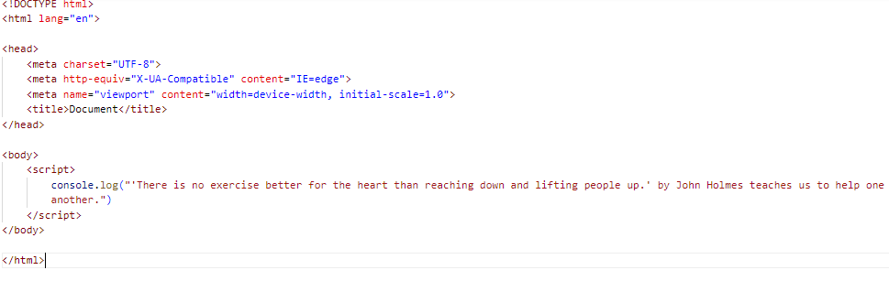

Output:

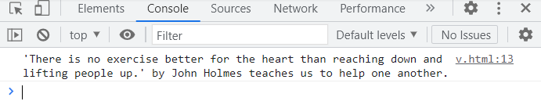

Q.7) Check if typeof '10' is exactly equal to 10. If not make it exactly equal?

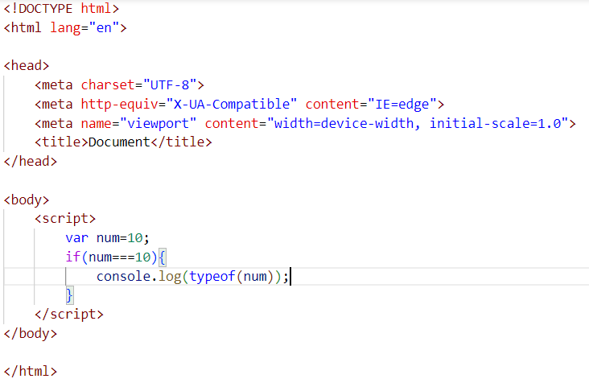

Output:

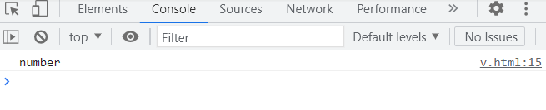

Q.8 Write a JavaScript Program to find the area of a triangle?

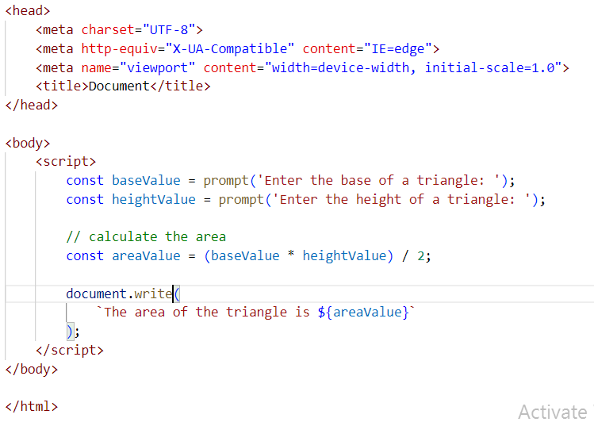

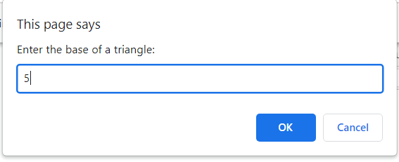 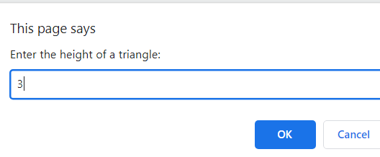

Output: 

Q.9 Write a JavaScript program to calculate days left until next Christmas?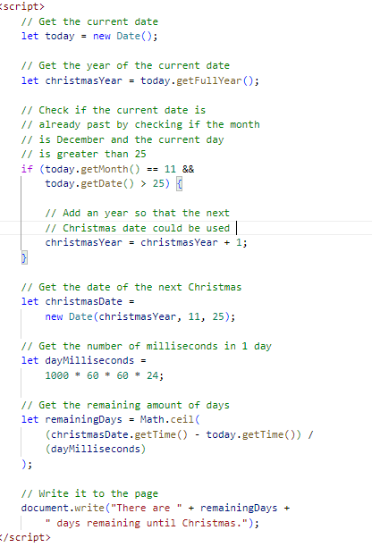

Output:

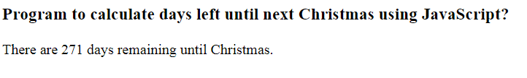

Q.10) What is Condition Statement?

A-10) In A JavaScript we have three forms of statement.

* if statement
* if else statement
* else if statement

1)if statement

* The if statement evaluated the condition inside the ().
* if the condition is evaluated to true , the code inside the body of if executed the code is

not executed

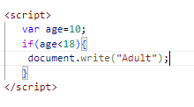

2) if else statement:

* The else statement is used to specify a block of code to be executed if a condition is not met.

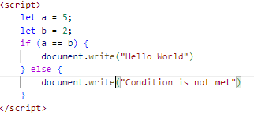

Output:



3) else if statement:

The else if statement is used to specify a new condition to be tested if the first condition is not met. This can be used when there’s more than one condition to be tested.

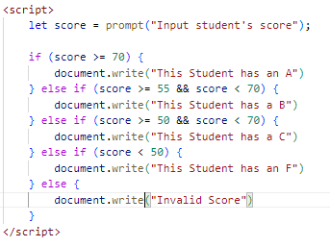

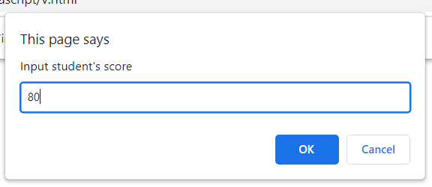

Output:



Q.11 Find circumference of Rectangle formula: C = 4 * a?

A-11)

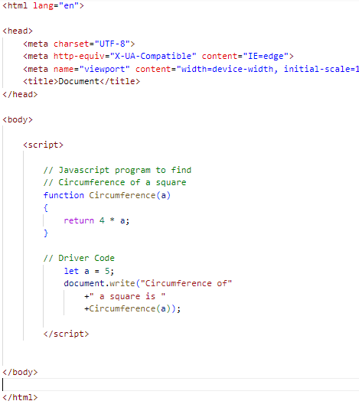

Output:



Q.12 WAP to convert years into days and days into years?

A-12)

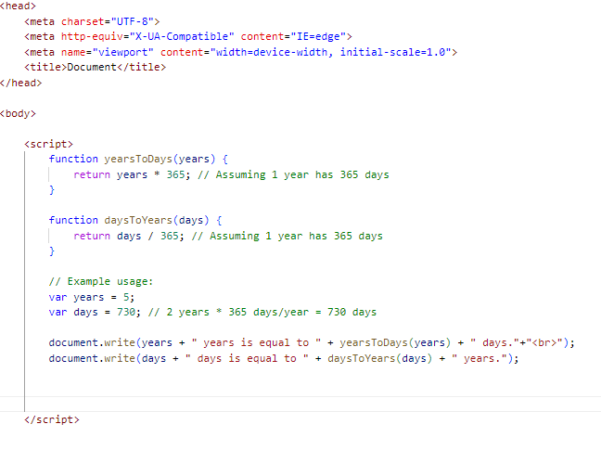

Output:



Q.13 Convert temperature Fahrenheit to Celsius? (Conditional logic Question).

A-13)

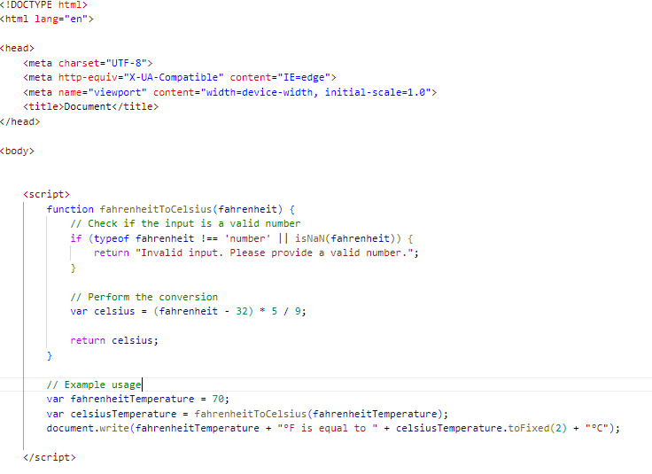

Output:



Q.14 Write a JavaScript exercise to get the extension of a filename.?

A-14)

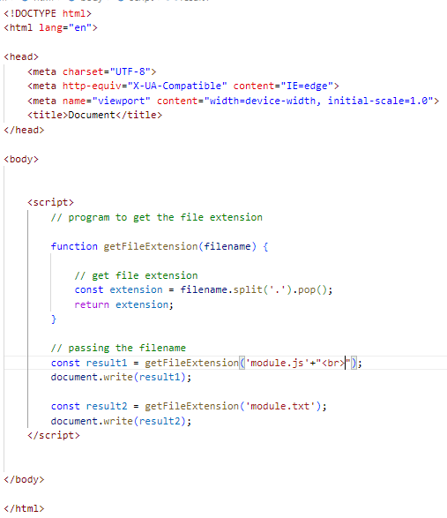

Output:



Q.15 What is the result of the expression (5 > 3 && 2 < 4)?

A-15)

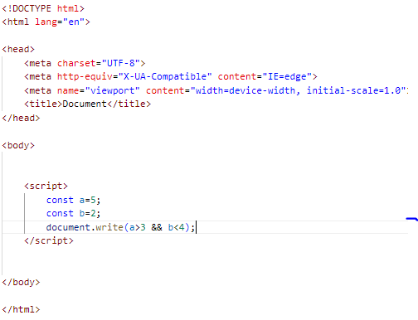

Output:



Q.16 What is the result of the expression (true && 1 && "hello")?

A-16)

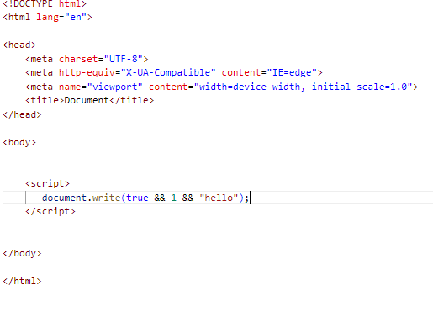

Output:



Q.17 What is the result of the expression true && false || false && true?

A-17)

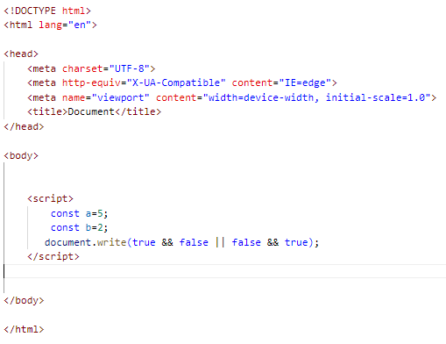

Output:



Q.18) What is a Loop and Switch Case in JavaScript define that?

A-18) In JavaScript, a loop is a programming construct that allows you to execute a block of code repeatedly until a specified condition is met. There are several types of loops in JavaScript, including:

* For loop: It repeats a block of code a specified number of times.

 for (initialization; condition; increment/decrement) {

        // code block to be executed

    }

* while loop: It repeats a block of code while a specified condition is true.

 while (condition) {

        // code block to be executed

    }

* do..while loop: It is similar to the while loop, but it always executes the block of code at least once before checking the condition.

    do{

            // code block to be executed

        } while (condition);

* Switch case is another programming construct used for decision-making. It provides an alternative to the if-else statements when you have multiple conditions to evaluate.

switch (expression) {

            case value1:

                // code block to be executed if expression matches value1

                break;

            case value2:

                // code block to be executed if expression matches value2

                break;

            // more cases can be added as needed

            default:

            // code block to be executed if expression doesn't match any case

        }

Q.19) What is the use of is Nan function?

A-19) In JavaScript Nan is short for "Not-a-Number".

The isNaN () method returns true if a value is NaN.

The isNaN () method converts the value to a number before testing it.

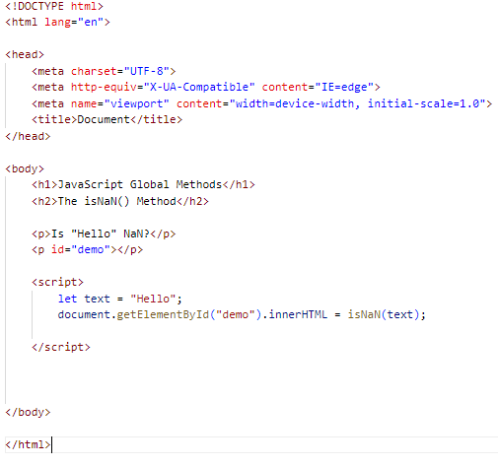

Output:

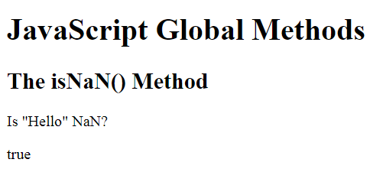

Q.20) What is the difference between && and || in JavaScript?

# A-20) Logical AND (&&): The **logical AND (**&&**)** operator for a set of Boolean operands will be true if and only if all the operands are true. Otherwise it will be false.

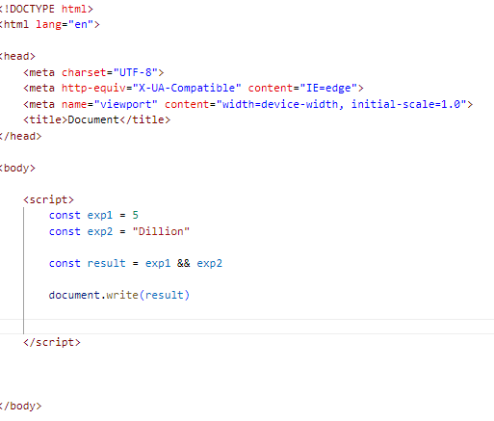

Output:



# Logical OR (||): The **logical OR (**||**)** operator for a set of operands is true if and only if one or more of its operands is true. It is typically used with boolean (logical) values. When it is, it returns a Boolean value.

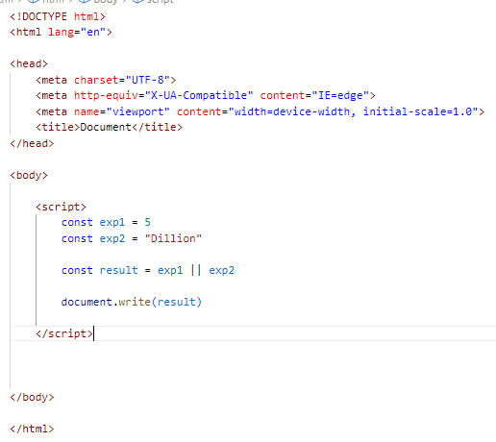

Output:



Q.21) What is the use of Void (0)?

A-21 void (0) means return undefined as a primitive value. We use this to prevent any negative effects on a webpage when we insert some expression.

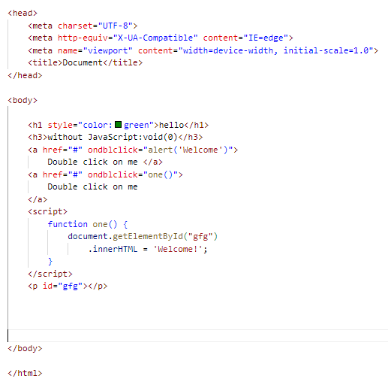

Output:

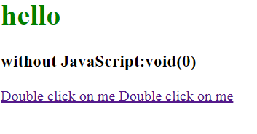

Q.22) Check Number Is Positive or Negative in JavaScript?

A-22) The Math.sign() method retuns whether a number is negative, positive or zero.

If the number is positive, this method returns 1.  
If the number is negative, it returns -1.  
If the number is zero, it returns 0.

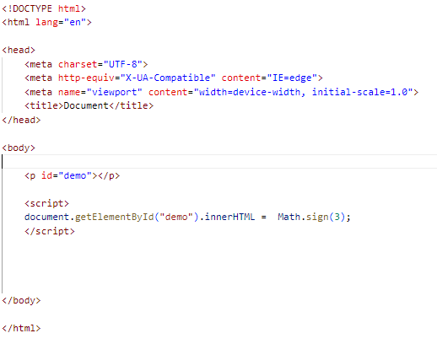

Output:



Q.23) Find the Character Is Vowel or Not ?A-23) 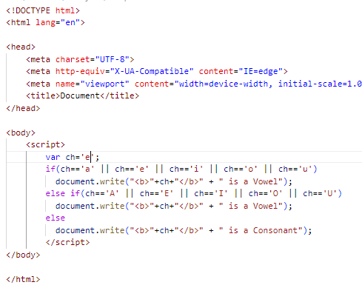

Output:



Q.24 Write to check whether a number is negative, positive or zero?

A-24)

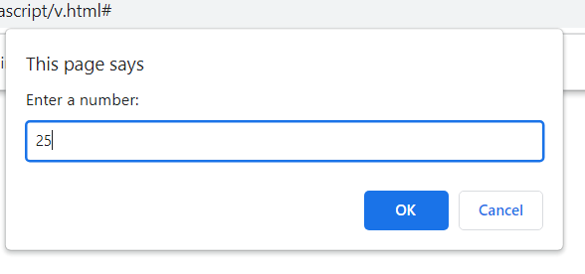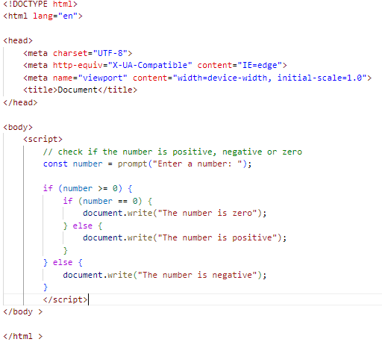

Output:



Q-25) Write to find number is even or odd using ternary operator in JS?

A-25)

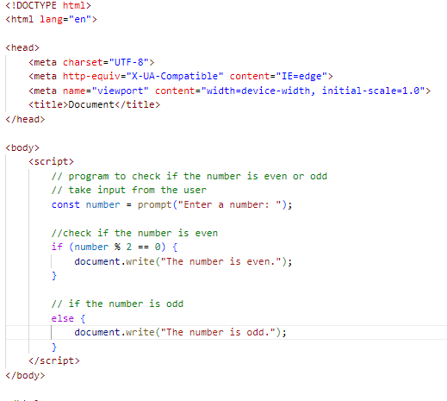

Output:

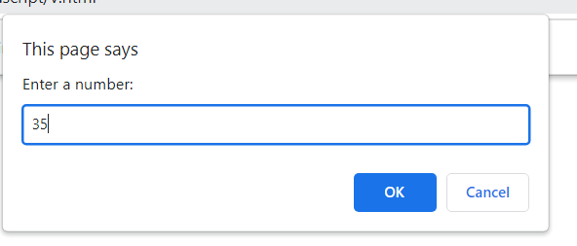



Q.26 Write find maximum number among 3 numbers using ternary operator in JS?A-26) 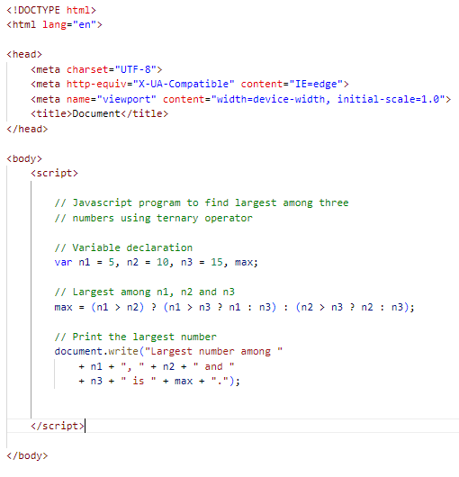

Output:



Q.27 Write to find minimum number among 3 numbers using ternary operator in JS?

A-27)

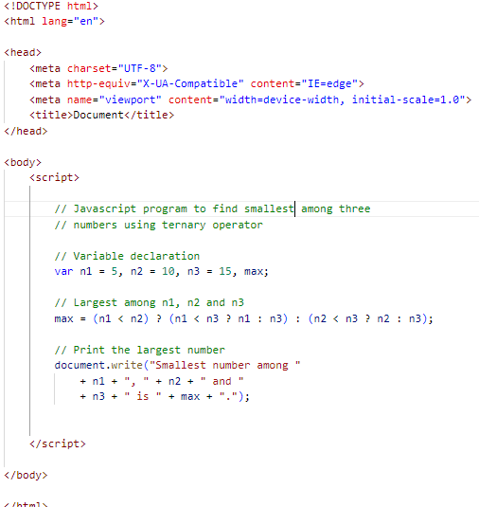

Output:



Q.28 Write to find the largest of three numbers in JS?

A-28)

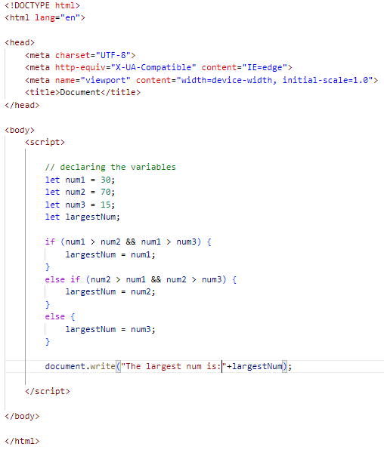

Output:



Q.29 Write to show?

i. Monday to Sunday using switch case in JS?

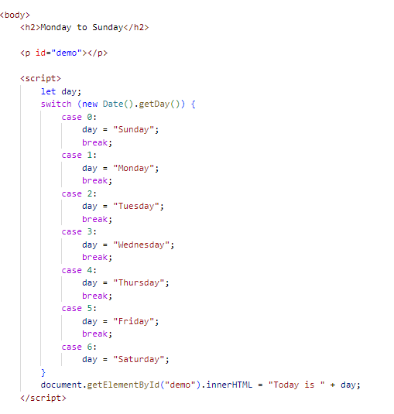

Output:

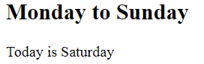

ii. Vowel or Consonant using switch case in JS?

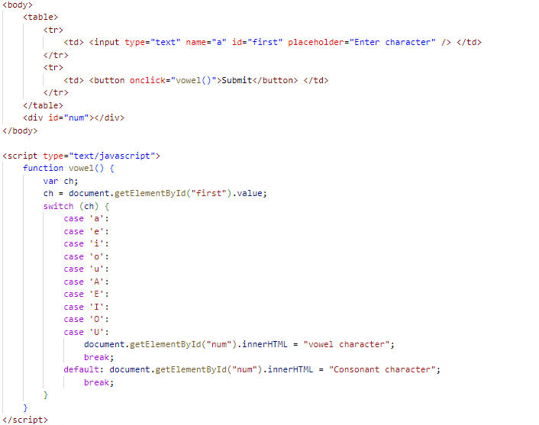

Output:

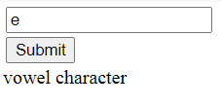

(Conditional looping logic Question)

Q.30) What are the looping structures in JavaScript? Any one Example?

A-30) we use loops to perform repeated actions. For example - if you are assigned a task of printing numbers from 1 to 100, it will be very hectic to do it manually, loops help us automate such tasks.

* types of loops:
* for loop
* for in loop
* for of loop
* while loop
* do-while loop

The for loop:

the syntax of a for loop something like this.

for(statement1;statement2;statement3)

{

//code to be executed;

}

example:

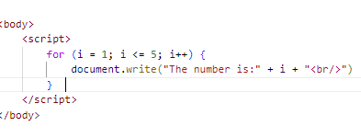

Output:

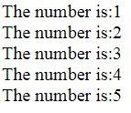

Q.31 Write a print 972 to 897 using for loop in JS?

A-31)

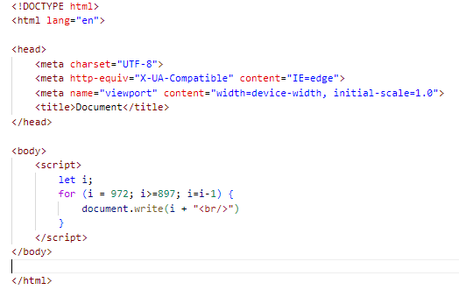 

Q.32 Write to print factorial of given number?

A-32)

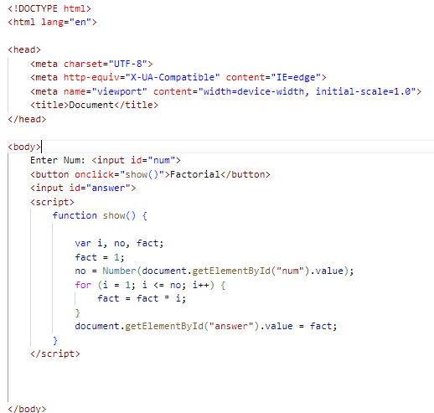

Output:



Q.33 Write to print Fibonacci series up to given numbers?

A-33)

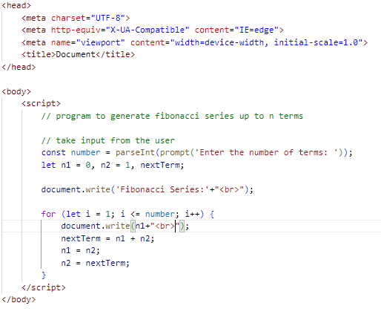

Output:

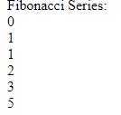

Q.34 Write to print number in reverse order e.g.: number = 64728 ---> reverse =82746 in JS?

A-34)

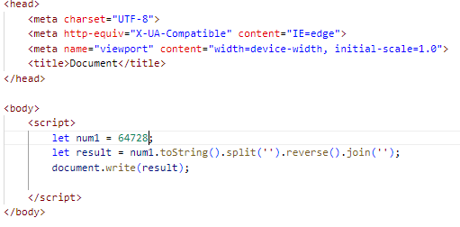

Output:



Q.35 Write a program make a summation of given number (E.g., 1523 Ans: - 11) in JS?

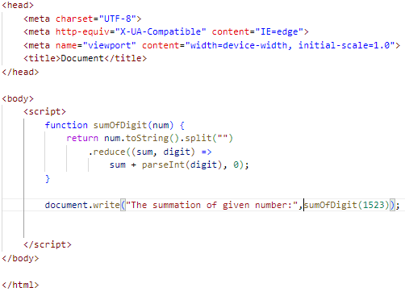

Output:



Q.36 Write a program you have to make a summation of first and last Digit.

(E.g., 1234 Ans: - 5) in JS?

A-36)

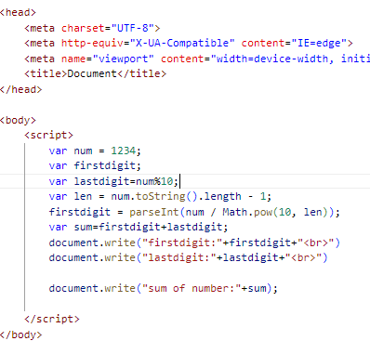Output:

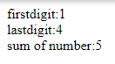

Q.37 Use console.log() and escape characters to print the following pattern in JS?

1 1 1 1 1

2 1 2 4 8

3 1 3 9 27

4 1 4 16 64

5 1 5 25 125

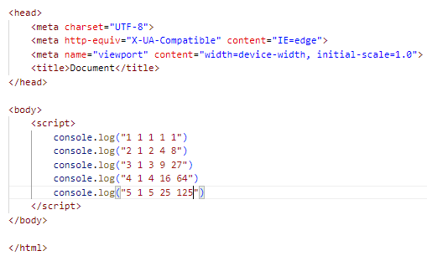

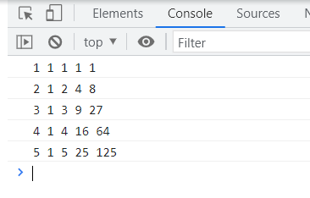

Q.38 Use pattern in console.log in JS?

1) 1

1 0

1 0 1

1 0 1 0

1 0 1 0 1

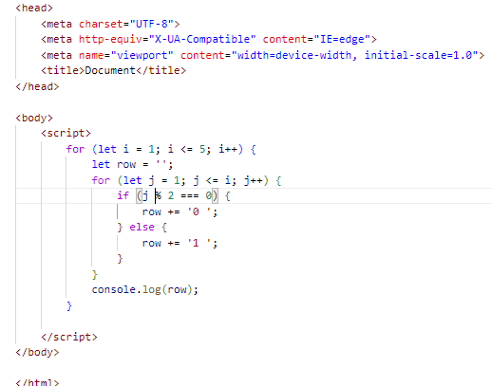

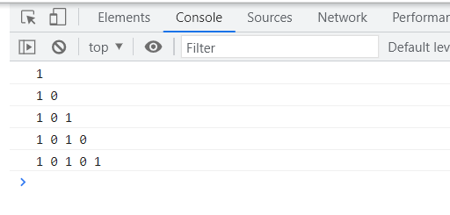

2)A

B C

D E F

G H I J

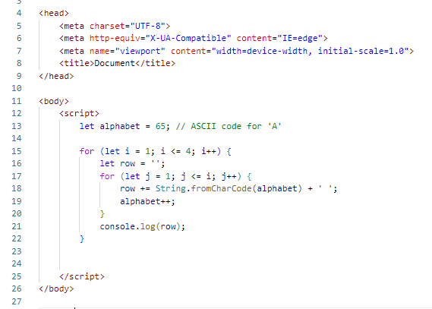

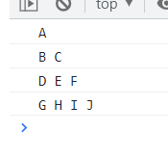

3) 1

2 3

4 5 6

7 8 9 10

11 12 13 14 15

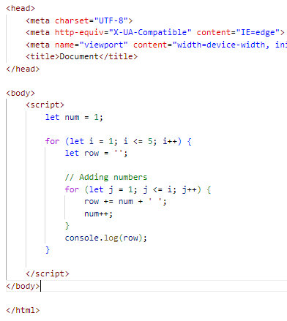

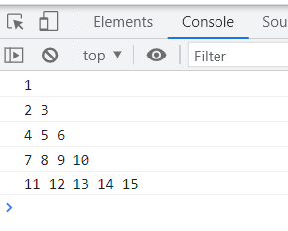

4) *

* *

* * *

* * * *

* * * * *

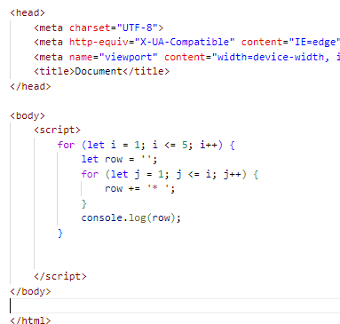

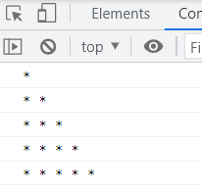

Q.39 Accept 3 numbers from user using while loop and check each numbers palindrome?

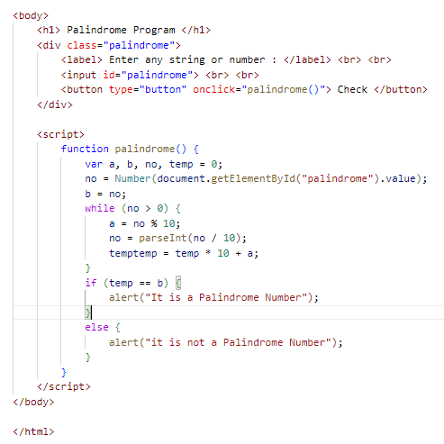

Output:

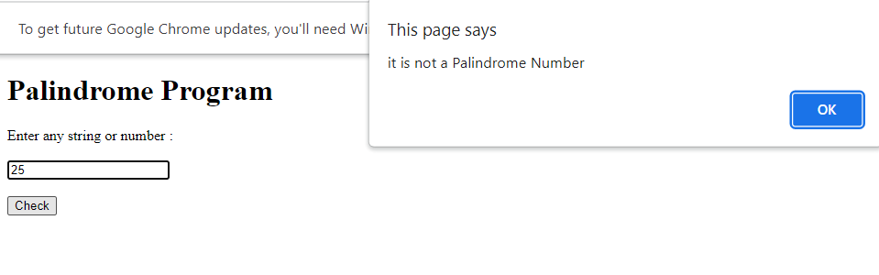

(Array and object Question)

Q.40 day Write a JavaScript Program to display the current and time in the following format. Sample Output: Today is Friday. Current Time is 12 PM: 12 : 22 2 ?

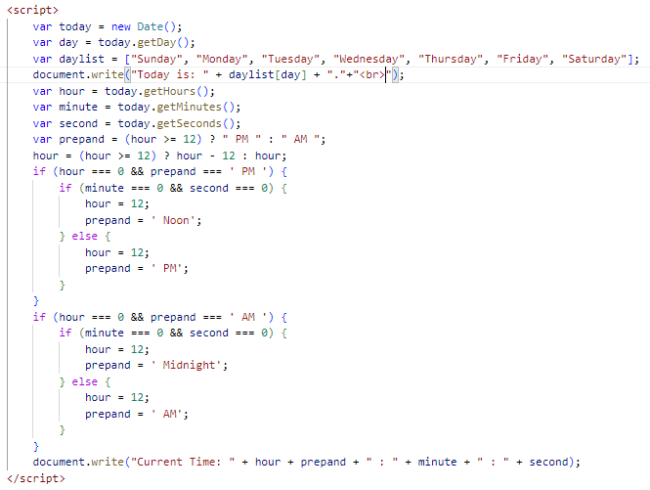

Output:



Q.41 Write a JavaScript program to get the current date?

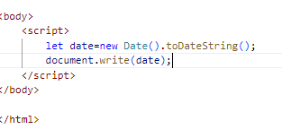

Output:



Q.42 Write a JavaScript program to compare two objects?

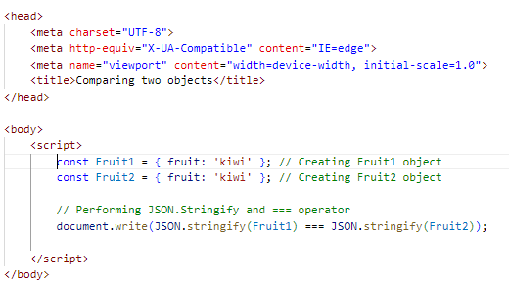

Output:



Q.43 Write a JavaScript program to convert an array of objects into CSV string?

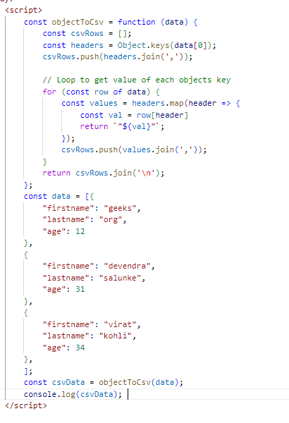

Output:

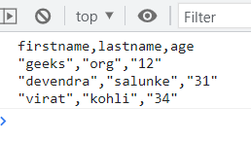

Q.44 Write a JavaScript program to capitalize first letter of a string?

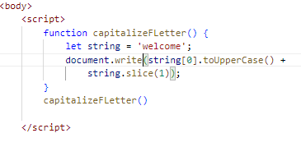

Output:



Q. 45 Write a JavaScript program to determine if a variable is array?

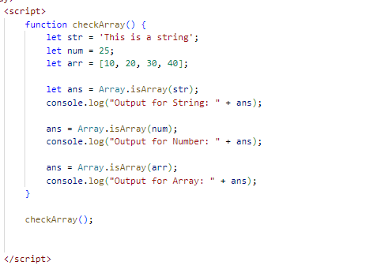

Output:

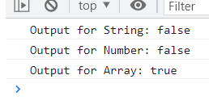

Q.46 Write a JavaScript program to clone an array?

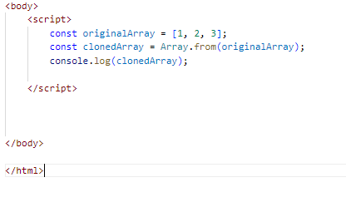

Output:



Q.47 ) What is the drawback of declaring methods directly in JavaScript objects?

A-47) One potential drawback of declaring methods directly in JavaScript objects is that it

can lead to increased memory usage, especially when you have multiple instances of

the object.

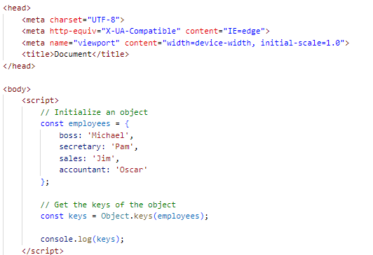

Output:



Q.48 Print the length of the string on the browser console using console.log()?

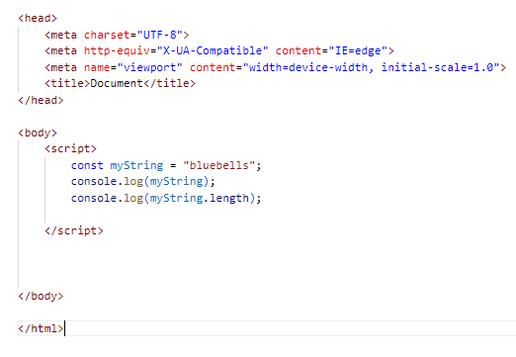

Output:

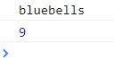

Q.49 Change all the string characters to capital letters using toUpperCase() method?

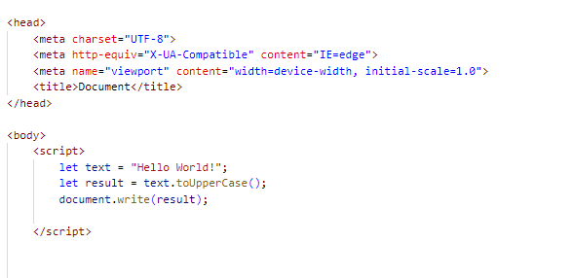

Output:



Q.50 What is the drawback of declaring methods directly in JavaScript objects?

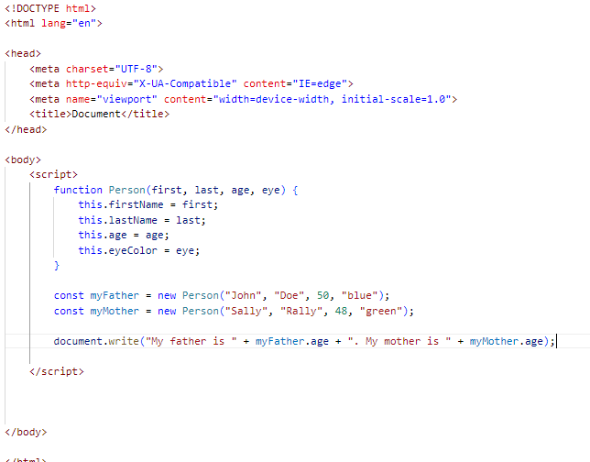

Output:



Q.51 Write a JavaScript program to get the current date.

Expected Output: mm-dd-yyyy, mm/dd/yyyy or dd-mm-yyyy, dd/mm/yyyy?

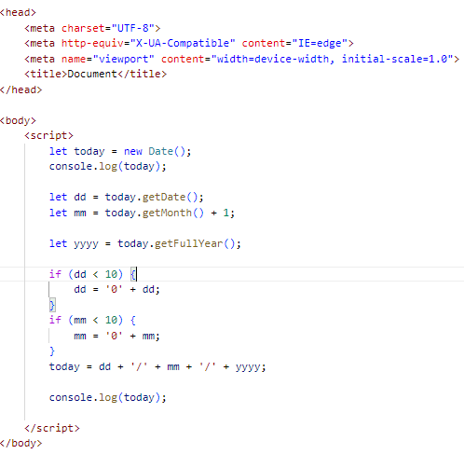

Output:

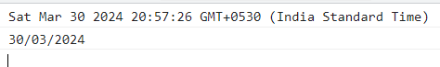

Q.52 Use indexOf to determine the position of the first occurrence of a in 30 Days Of JavaScript?

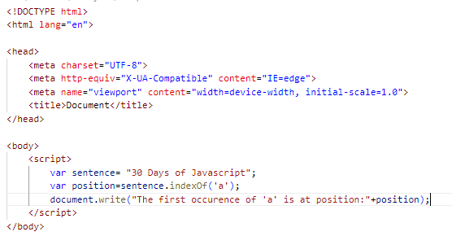

Output:



Q.53 Use lastIndexOf to determine the position of the last occurrence of a in 30 Days Of JavaScript?

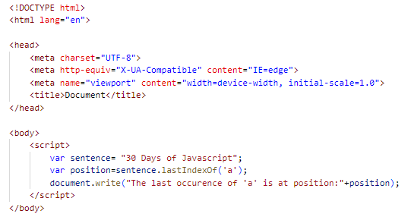

Output:



Q.54) Form Validation in JS?

A-54) Form validation is the process of verifying that the data entered into an HTML form is accurate, complete, and meets the specified criteria.

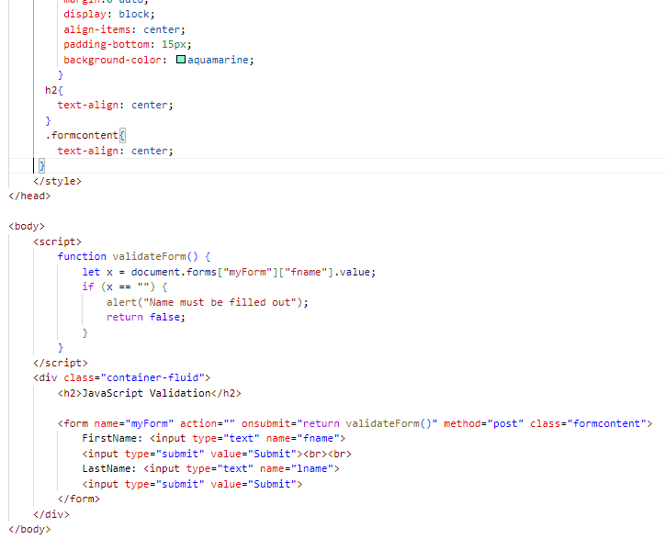

Output:

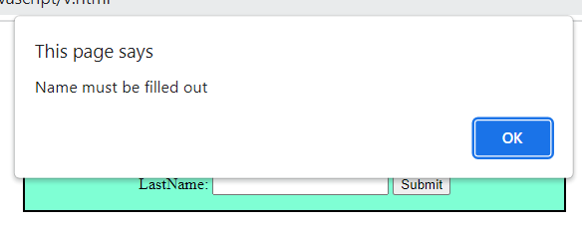

Q.55 Form in Email, number, Password, Validation?

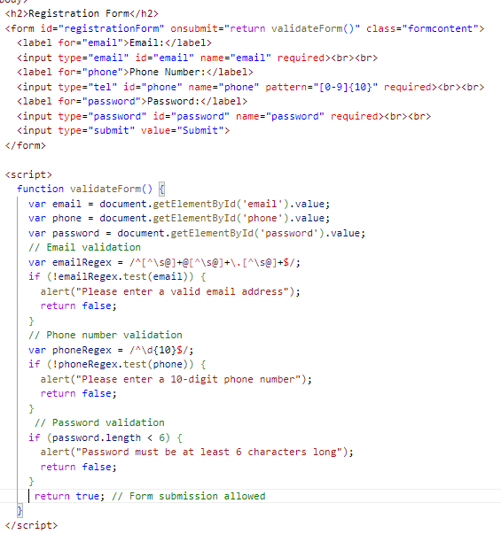

Output:

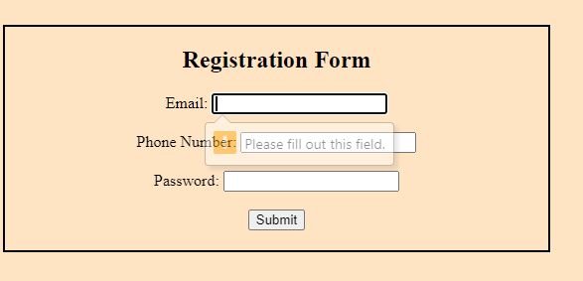

Q.56 Dynamic Form Validation in JS?

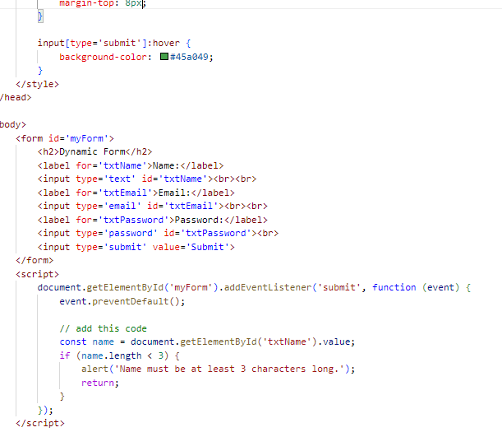

Output:

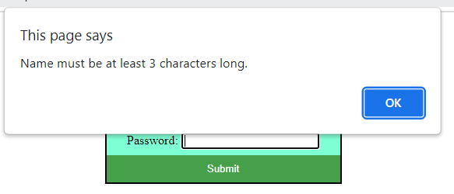

Q.57) how many type of JS Event? How to use it?

A-57) JavaScript has Event to provide a dynamic interface to a webpage. These events are

hooked to element in the Document object model.

* Common JavaScript Events
* Mouse Events: Event Performed. Event Handler. Description. click. onclick. ...
* Keyboard Events: Event Performed. Event Handler. Description. Keydown & Keyup. ...
* Form Events: Event Performed. Event Handler. Description. focus. ...
* Window or Document Events: Event Performed. Event Handler. Description. load.

* onclick Event Type : This is the most frequently used event type which occurs when a user clicks the left button of his mouse. You can put your validation, warning etc., against this event type.

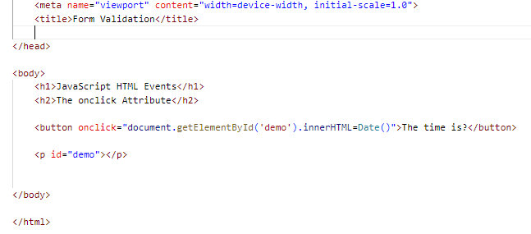

Output:

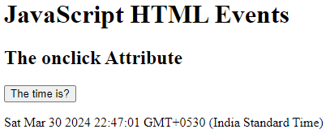

* onsubmit Event type :onsubmit is an event that occurs when you try to submit a form. You can put your form validation against this event type.

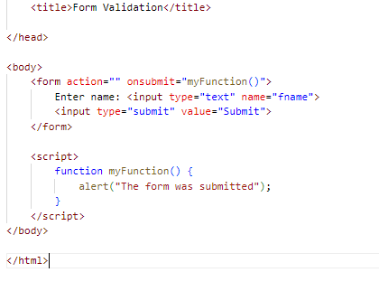

Output:

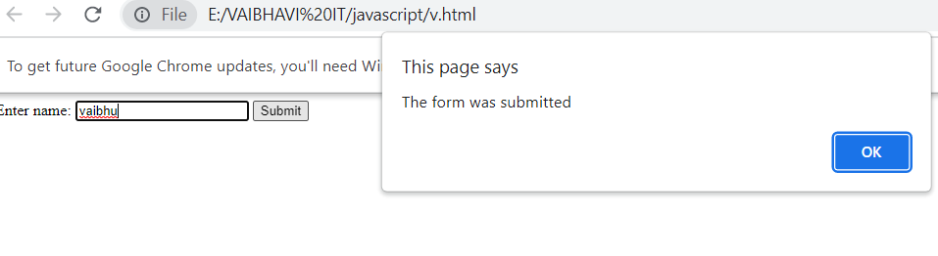

Q.59 What is Bom vs Dom in JS?

| Document Object Model (DOM) | Browser Object Model (BOM) |
| --- | --- |
| It mainly focuses on the structure of the displayed document. | It mainly focuses on browser-specific functionality. |
| It facilitates a standardized interface to access and modify the elements and content of an HTML or XML document. | It allows JavaScript to interact with browser features beyond the scope of manipulating the document structure. |
| When an HTML document gets loaded in the browser, then it becomes a document object. | In this case, the window object will be created automatically by the browser. |
| It facilitates access and manipulation, along with dynamically updating the structure, content, and styling of the web document. | It facilitates the different functionality for governing the browser window, handling the navigation, managing history, and accessing browser-related information. |
| It provides direct access control to the content of the web document, along with permitting the traversal and modification of its elements and attributes. | It doesn’t have any access to the content of the web document directly. |

Q.60 Array vs object defences in JS?

|  |  |
| --- | --- |
| Array | Object |
| Arrays are a special type of variable that is also mutable and can also be used to store a list of values. | Objects represent a special data type that is mutable and can be used to store a collection of data. |
| We use arrays whenever we want to create and store a list of multiple items in a single variable. | Objects are used to represent a “thing” in your code. That could be a person, a car, a building, a book, a character in a game — basically anything that is made up or can be defined by a set of characteristics. |
| Arrays use zero-based indexing, so the first item in an array has an index of 0, the second item an index of 1, and so on. | Properties in objects can be accessed, added, changed, and removed by using either **dot** or **bracket** notation. |

Q.61 Split the string into an array using split() Method?

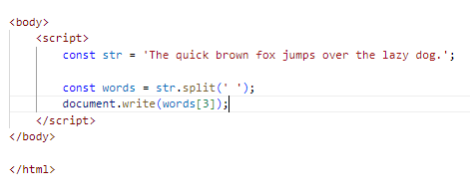

Output:



Q.62 Check if the string contains a word Script using includes() method?

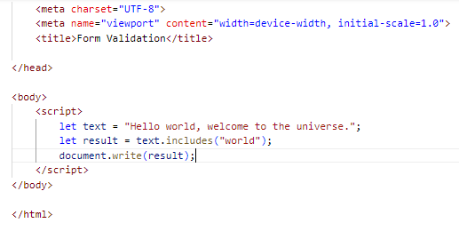

Output:



Q.63 Change all the string characters to lowercase letters using to Lowercase () Method.

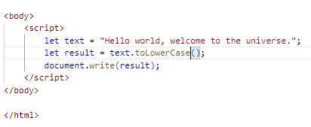

Output:



Q.64 What is Character at index 15 in ’30 Days of JavaScript’ string? Use char At () method.

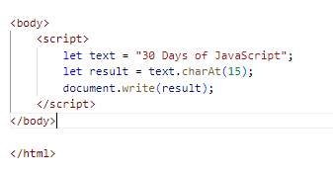

Output:



Q.65 copy to one string to another string in JS?

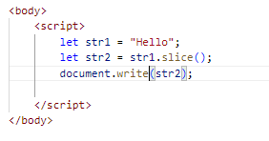

Output:



Q.66 Find the length of a string without using library Function?

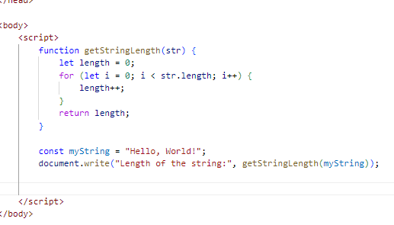

Output:



Q-1) What is JavaScript?

Ans.)JavaScript is a scripting language that enables you to create dynamically updating

content, control multimedia, animate images, and pretty much ...

Q-2) What is the use of isNaN function?

Ans.) The JavaScript isNaN () Function is used to check whether a given value is

an illegal number or not.

Q-3) What is negative Infinity?

Ans.) Negative Infinity is special num is returned when an arithmetic operation or

mathematical generates a negative value greater than the largest representable

JavaScript.

Q-4) Which company developed JavaScript?

Ans.) JavaScript was originally developed by Brendan Erich at Netscape Communications Corporation.

Q-5) What are undeclared and undefined variables?

Ans.) Undefined: it occurs when a variable has been declared but has not been assigned

any value. Undefined is not a Keyword.

B) Undeclared: it occurs when we try to access an variable that is not initialized or

declared earlier using the var or const keyword.

Q-6) Write the code for adding new elements dynamically?

Ans.)

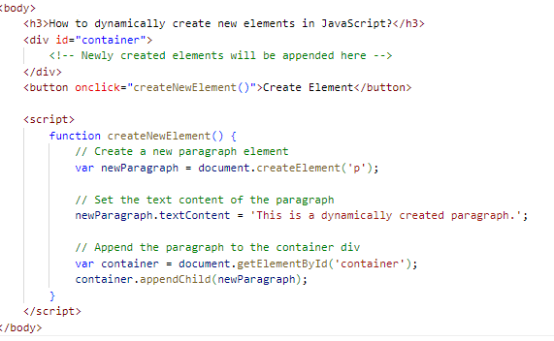

Output:

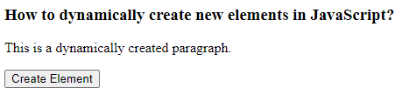

Q-7) What is the difference between View State and Session State?

Ans.)

| View State | Session State |
| --- | --- |
| Maintained at page level only. | Maintained at session level. |
| View state can only be visible from a single page and not multiple pages. | Session state value availability is across all pages available in a user session. |
| It will retain values in the event of a post back operation occurring. | In session state, user data remains in the server. Data is available to user until the browser is closed or there is session expiration. |
| Information is stored on the client’s end only. | Information is stored on the server. |

Q-8) What is = = = operator?

Ans.) The strict equality (= = =) operator checks whether its two operands are equal,

returning a Boolean result.

Q-9) How can the style/class of an element be changed?

Ans.)

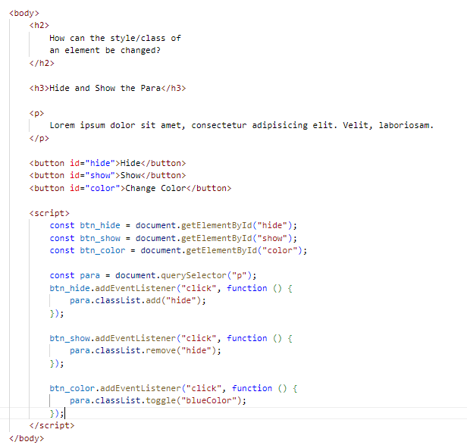

Output:

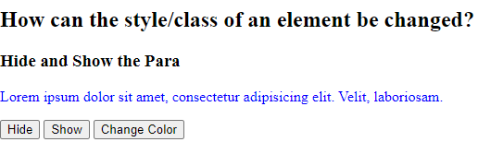

Q-10) How to read and write a file using JavaScript?

## Ans.)

## Write operation on a file: After the File System file is imported then, the writeFile () operation is called. The writeFile () method is used to write into the file in JavaScript.

## Reading from the file: After the File System module is imported, the reading of the file in JavaScript can be done by using the readFile () function.

Q-11)What are all the looping structures in JavaScript?

Ans.) There are kind of loops you will find in JavaScript.

1) For Loop: The for loop repeats a block of code a specified number of times. It consists of three parts: initialization, condition, and increment/decrement.

For (initialization; condition; increment/decrement){

//code of block to be execute

}

2) **while loop**: The while loop repeats a block of code while a specified condition is true.

while(conidition){

//code block to be executed

}

3) **do...while loop**: The do...while loop is similar to the while loop, but the condition is

checked after the block of code is executed. This ensures that the code block is executed

at least once.

do{

//code of block to be executed

}while(condition);

4) **for...in loop**: The for...in loop iterates over the enumerable properties of an object, in

arbitrary order. It is used for iterating over the properties of an object.

for(variable in object)

{

//code block to be executed

}

5) there's also the for...of loop which iterates over iterable objects like arrays, strings

maps, sets, etc.

for(variables of iterable)

{

//code block to be executed

}

Q-11) How can you convert the string of any base to an integer in JavaScript?

Ans.)

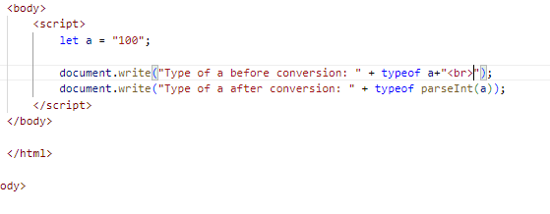

Output:



Q-12) What is the function of the delete operator?

Ans.)

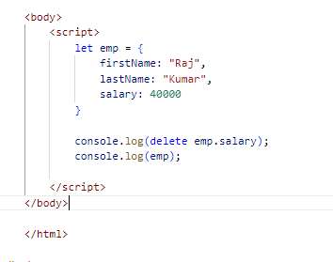

Output:

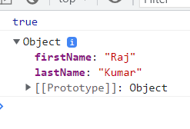

Q-13) What are all the types of Pop up boxes available in JavaScript?

Ans.) JavaScript has three kind of popup boxes: Alert box, Confirm box, and Prompt box.

* Alert Box:The ‘alert ()’function is used to display an alert dialog box with a specified message or ok button.

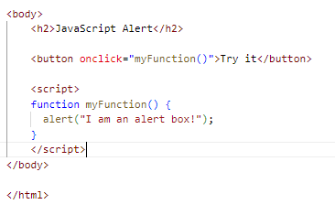

Output:

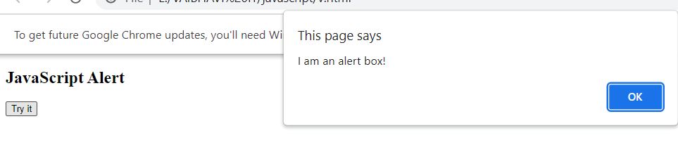

## Confirm Box: A confirm box is often used if you want the user to verify or accept something.

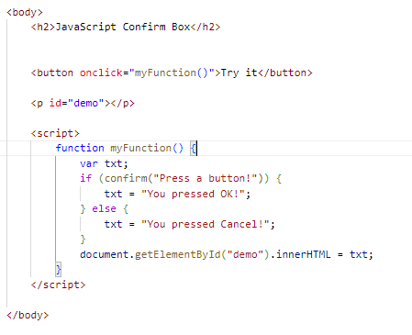

Output:

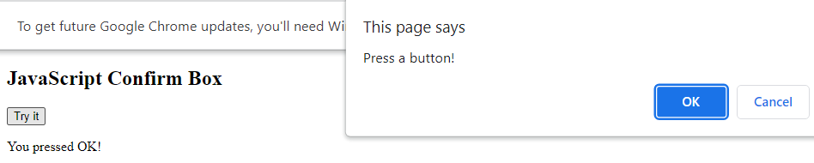

## Prompt Box: A prompt box is often used if you want the user to input a value before entering a page.

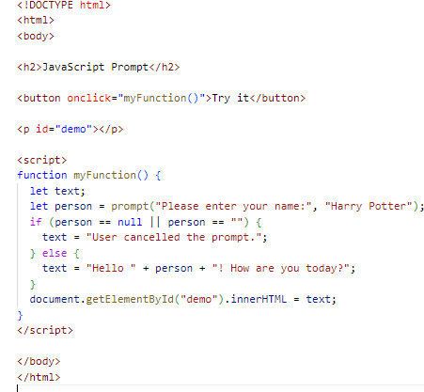

Output: 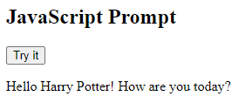

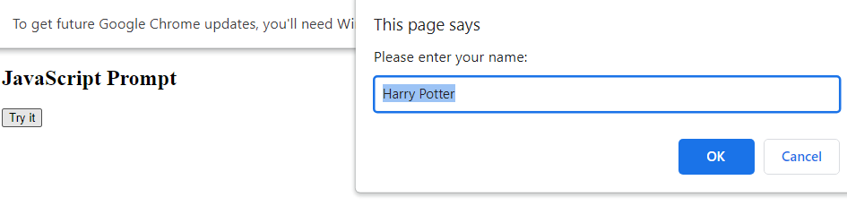

Q-14) What is the use of Void (0)?

Ans.) The void operator evaluates an expression and returns undefined. By running void (0) in the URL JavaScript code, nothing is evaluated or return.

Q-15) How can a page be forced to load another page in JavaScript?

Ans.)

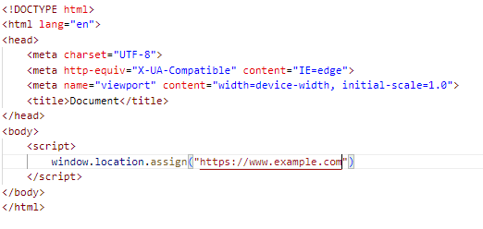

Output:

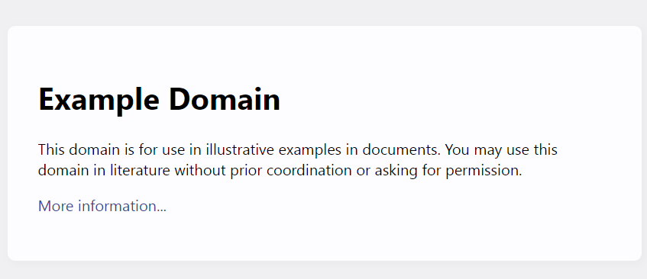

Q-16) What are the disadvantages of using innerHTML in JavaScript?

Ans.)

* **The use of innerHTML very slow**
* **Preserves event handlers attached to any DOM elements**
* **Content is replaced everywhere**
* **Appending to innerHTML is not supported**